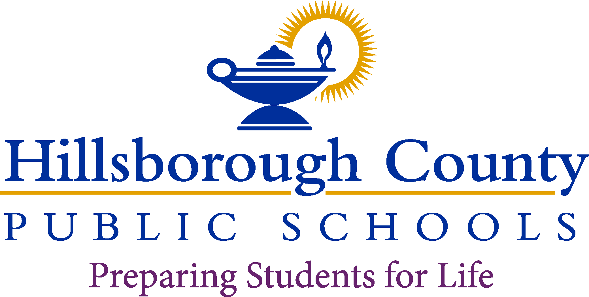

**Superintendent of Schools**

Addison G. Davis

Principal

Krissy J. Perkins, Ed. D

Assistant Principal

Olga Patino

**School Board**

Nadia T. Combs, Chair

Henry “Shake” Washington, Vice Chair

Lynn L. Gray

Stacy A. Hahn, Ph.D.

Karen Perez

Melissa Snively

Jessica Vaughn

**Trapnell Elementary School**

February 8, 2022

Dear Parents/Guardians:

All educators in Florida are monitored to ensure they meet certification and training requirements as mandated by law. Per Florida Statute 1012.42, when a teacher is assigned teaching duties out of the field in which the teacher is certified, the parents of all students in the class shall be notified in writing.

Hillsborough County Public Schoolsis committed to providing quality instruction for all students and does so by employing the most qualified individuals to teach and support each student in the classroom. The district is assisting our teachers by developing an *Individual Professional Development Plan* to complete the requirements needed to become in-field.

All of our teachers are certified to teach, although some of them are currently out-of-field and are working on additional areas of certification. You have the right to know the professional qualifications of the teachers or paraprofessionals who instruct your child. Federal law allows you to ask for certain information about your child’s teachers and requires us to give you this information in a timely manner if you ask for it. If you would like more information, please contact the school at 813-757-9313.

The table below lists teachers who are currently out-of-field.

Sincerely,

Krissy Perkins

Principal

|  |  |  |  |  |
| --- | --- | --- | --- | --- |
| **Teacher** | **Classes Taught**  **Assignment(s)** | **Assignment Start Date** | **Certification(s) Held** | **Out-of-Field**  **Area/Classes** |
| Maria Padilla | 3nd grade | August 10th, 2021 | Social Science 6-12  Elementary Education K-6 | ESOL |